STONEDOG PRODUCTIONS
60 SWINLEY HOUSE, REDHILL STREET, LONDON, UK/ +44 7491 333424 / DIRECTOR@STONEDOG.INFO

PRESS RELEASE: (USE IMMEDIATELY) / DATE: 18 JANUARY 2021 / DATELINE: LONDON

FILM NEWS: A TALE OF ARTISTIC TRIUMPH UNDER LOCKDOWN

Genre: Documentary Short / Running Time: 31.20 minutes / Format: HD

London film collective Stonedog Productions releases Linda Karshan: Covid-19 Conversation, an inspiring documentary about American artsist Linda Karshan’s historic rebirth under Covid-19 lockdown.

While under Covid-19 lockdown in New York, Linda Karshan recalled her father’s crippling polio affliction in the 1952/53 epidemic, the social alienation, and his gallant battle against it. This inspired her to “push back” by producing her most prolific body of work to date, “…because I can stand, and he could not.”

Karshan’s father, Roger E. Joseph, was a decorated World War II hero, outlived his doctor’s pessimistic prognosis by sixteen years, during which he resumed his legal practice in his family’s law chambers.

Directed by London-based Ghanaian filmmaker Ishmael Fiifi Annobil, Linda Karshan: Covid-19 Conversation shows Linda Karshan at her most eloquent, offering a rare insight into her inner and outer impulses during her “channelling” of the unique art pieces, and the influential role her agent, Jill Silverman van Coenegrachts, played by throughout that process.

Covid-19 Conversation evokes Linda Karshan’s profound art practice, her magnificent exhibitions, and her groundbreaking ‘Walked Drawing’ genre, interspersed with poignant anecdotes from the collective memories of her family, and the heroism of her father, Roger E. Joseph, in World War II.

Covid-19 Conversation is rich with poignant anecdotes from the collective memories of Linda and her sisters, lavishly interspersed with telling family photography. It also offers a mesmerising tableau of the Covid Works, photographed in-situ by Linda’s son, Roger Karshan, and her studio manager Allison Wucher.

“Covid-19 Conversation is a testament to human resilience, and to the role of memory in the mark making of artists. It is Linda’s requiem for her father,” says Ishmael Fiifi Annobil.
FREE OF CHARGE: The whole Covid-19 Conversation film is on free release via Youtube and the film’s website, and can be acquired for TV and Cable transmission:

Youtube URL: https://youtu.be/0aja6kUabpI
Film’s Website: www.covid19conversation.info

Producer/Director/Editor: Ishmael Fiifi Annobil
Associate Producer: Jill Silverman van Coenegrachts
Cinematography/Sound: Max Mallen
Audio Post-Production: Nick Kulukundis

ENDS

EDITORS’ NOTES:
- P.T.O for Biographical notes.
- For the Film’s Trailer, Press Releases, Images, Film’s Poster downloads, and more info, visit the Media Room of the film’s website: www.covid19conversation.info

- To requests interviews with Linda Karshan, contact: Jill Siverman van Coenegrachts at info@jsvcprojects.com / website: www.jsvcprojects.com

- Related websites: lindakarshanstudio.com / stonedog.info / thelindakarshanfilm.com
BIOGRAPHICAL NOTES: LINDA KARSHAN

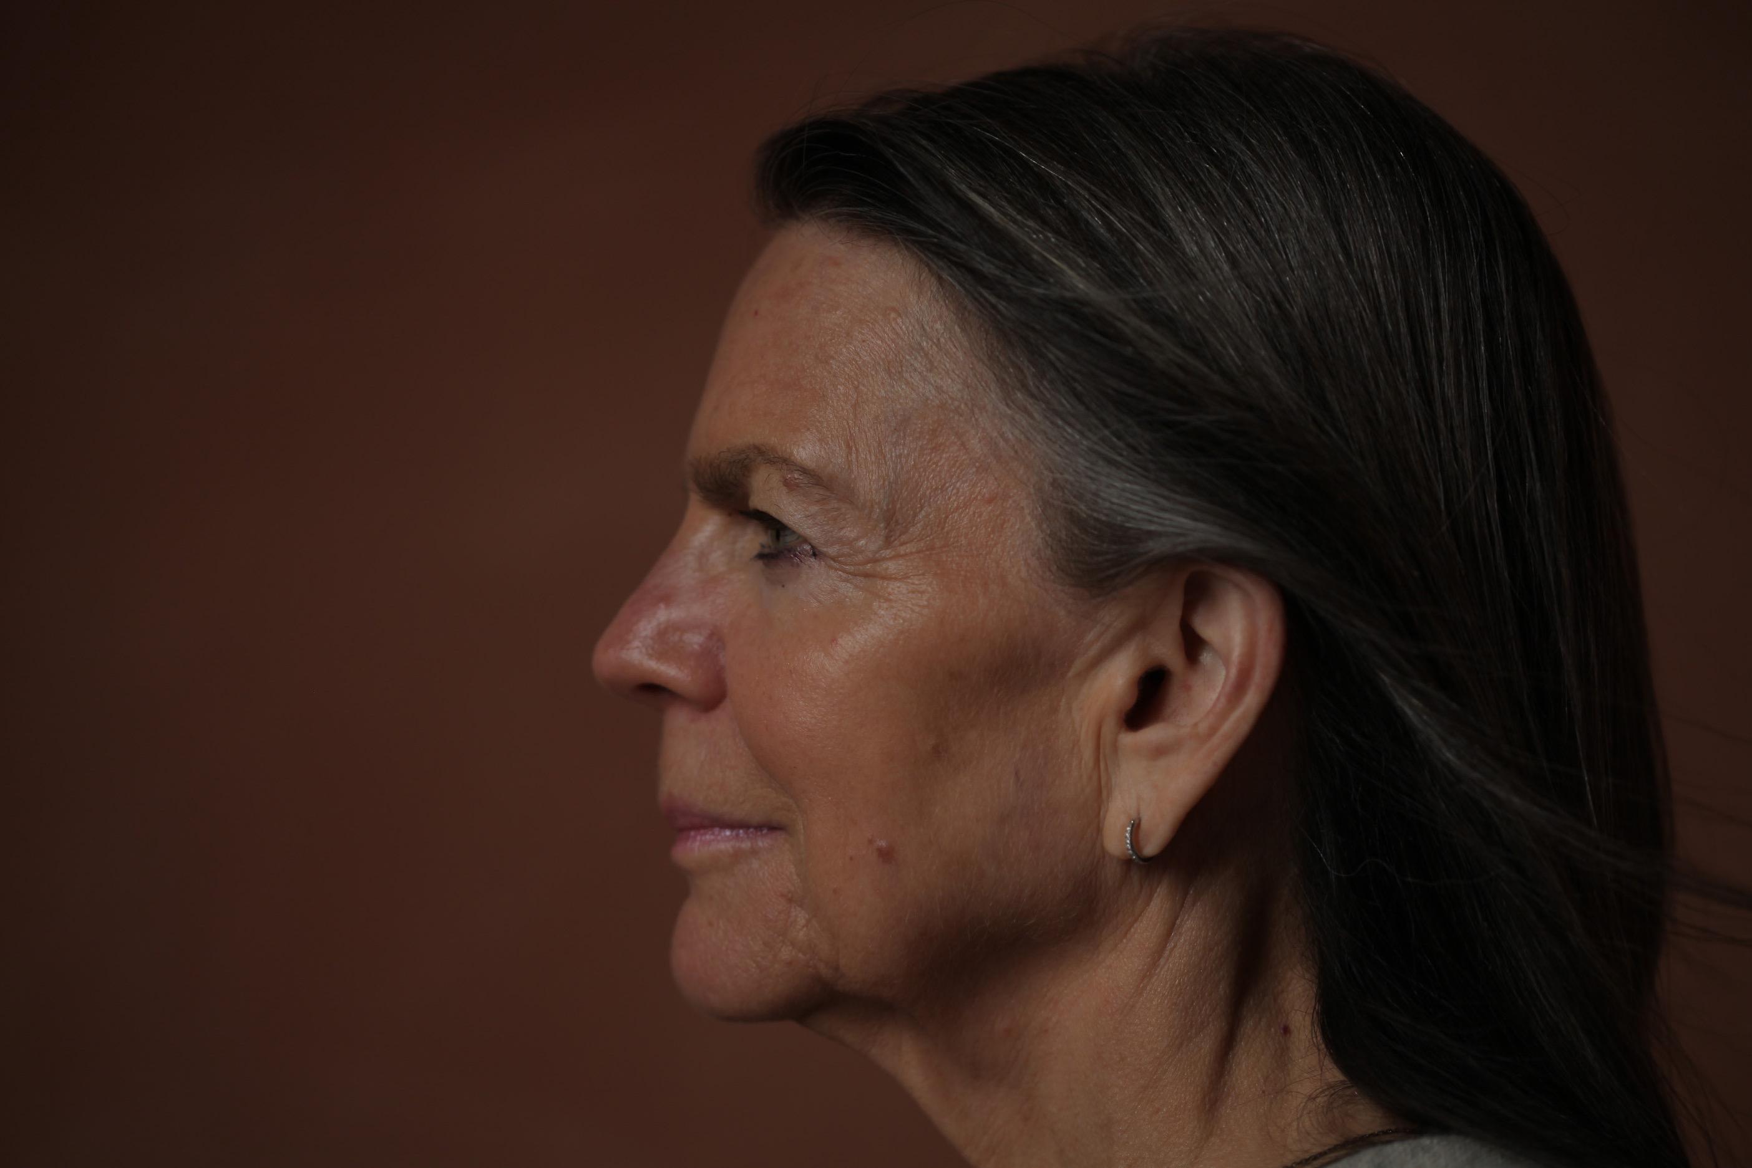

Linda Karshan is an American minimalist artist with an eminent practice that straddles the Atlantic. Drawing, printmaking, coupled with ambulatory and neo-choreographic technique, are the vehicles for her artistic expression, which is characterised by a disarming simplicity of form. She is noted for an irrepressible inventiveness that disregards boundaries (or edges), leading to groundbreaking outcomes, such as her ‘walked drawing’ genre, which entails her employing her feet as drawing points to enact walked lines and movements that reflect her internal rhythm. Drawing for Linda Karshan is a means of bridging the gap between a purely inner reality and a shared external reality, objectively perceived in the “transitional space” between the conscious and the unconscious. She draws with a method, but no plan, using her inner choreography and balletic norms for kinesis (see Linda Karshan: Movements, and Their Images and Linda Karshan: Choreographic Aspect)

Linda Karshan has a profound affinity with the lyricism of Greco-Roman text, art, and geometric archetypes; especially the Greek Cross, which underpins all her work. Her alter egos include Leonardo Da Vinci, Piero della Francesca, Cicero, and Samuel Beckett. Born in Minneapolis to a family of Jewish Romanian background, Linda Karshan has been resident in London since 1968. Her magnificent exhibitions include Equilibrio - Linda Karshan: Art, Architecture & Sacred Geometry in Conversation, San Giorgio Maggiore, Venice; Retrospective Drawing Exhibition 1992-2019 at DRAW Art Fair, Saatchi Gallery, London; and The Library for L’Aquila by Linda Karshan, for Nine Artists for Reconstruction, the library of Palazzo dell’Emiciclo, L’Aquila, Italy, and keynote shows at Galerie Werner Klein, Cologne, since 2008; Galerie Biedermann, Munich, since 1991; and Redfern Gallery, London, since 1995.
.
Linda Karshan’s drawings, prints and monographs are held in public and private collections, including the The British Library, The British Museum, The Courtauld Institute of Art, Sir John Soane’s Museum, Tate Modern, The Arts Council Collection, The Ashmolean Museum, Kettle’s Yard, Middlesbrough Museum of Modern Art (MIMA), Fine Arts Museums of San Francisco, Fogg Museum, Harvard University, Walker Art Center, Minneapolis, The Morgan Library, and Metropolitan Museum of Art has recently acquired thirteen of her prints.

Linda Karshan was educated at Skidmore College, Saratoga Springs, NY (1965-67); the Sorbonne, Paris (1967-68); and the Slade School of Art, University College London (1969). In 1983, she earned a Masters in Humanistic Psychology from Antioch Centre for British Studies, London. She has recently been made an Honorary Trustee of The Courtauld Institute. She is represented by Jill Silverman van Coenegracts (JSVCProjects) and The Redfern Gallery, London.

WEB: lindakarshanstudio.com | jsvcprojects.com | www.redfern-gallery.com | thelindakarshanfilm.com

BIOGRAPHICAL NOTES: ISHMAEL FIIFI ANNOBIL (DIRECTOR)

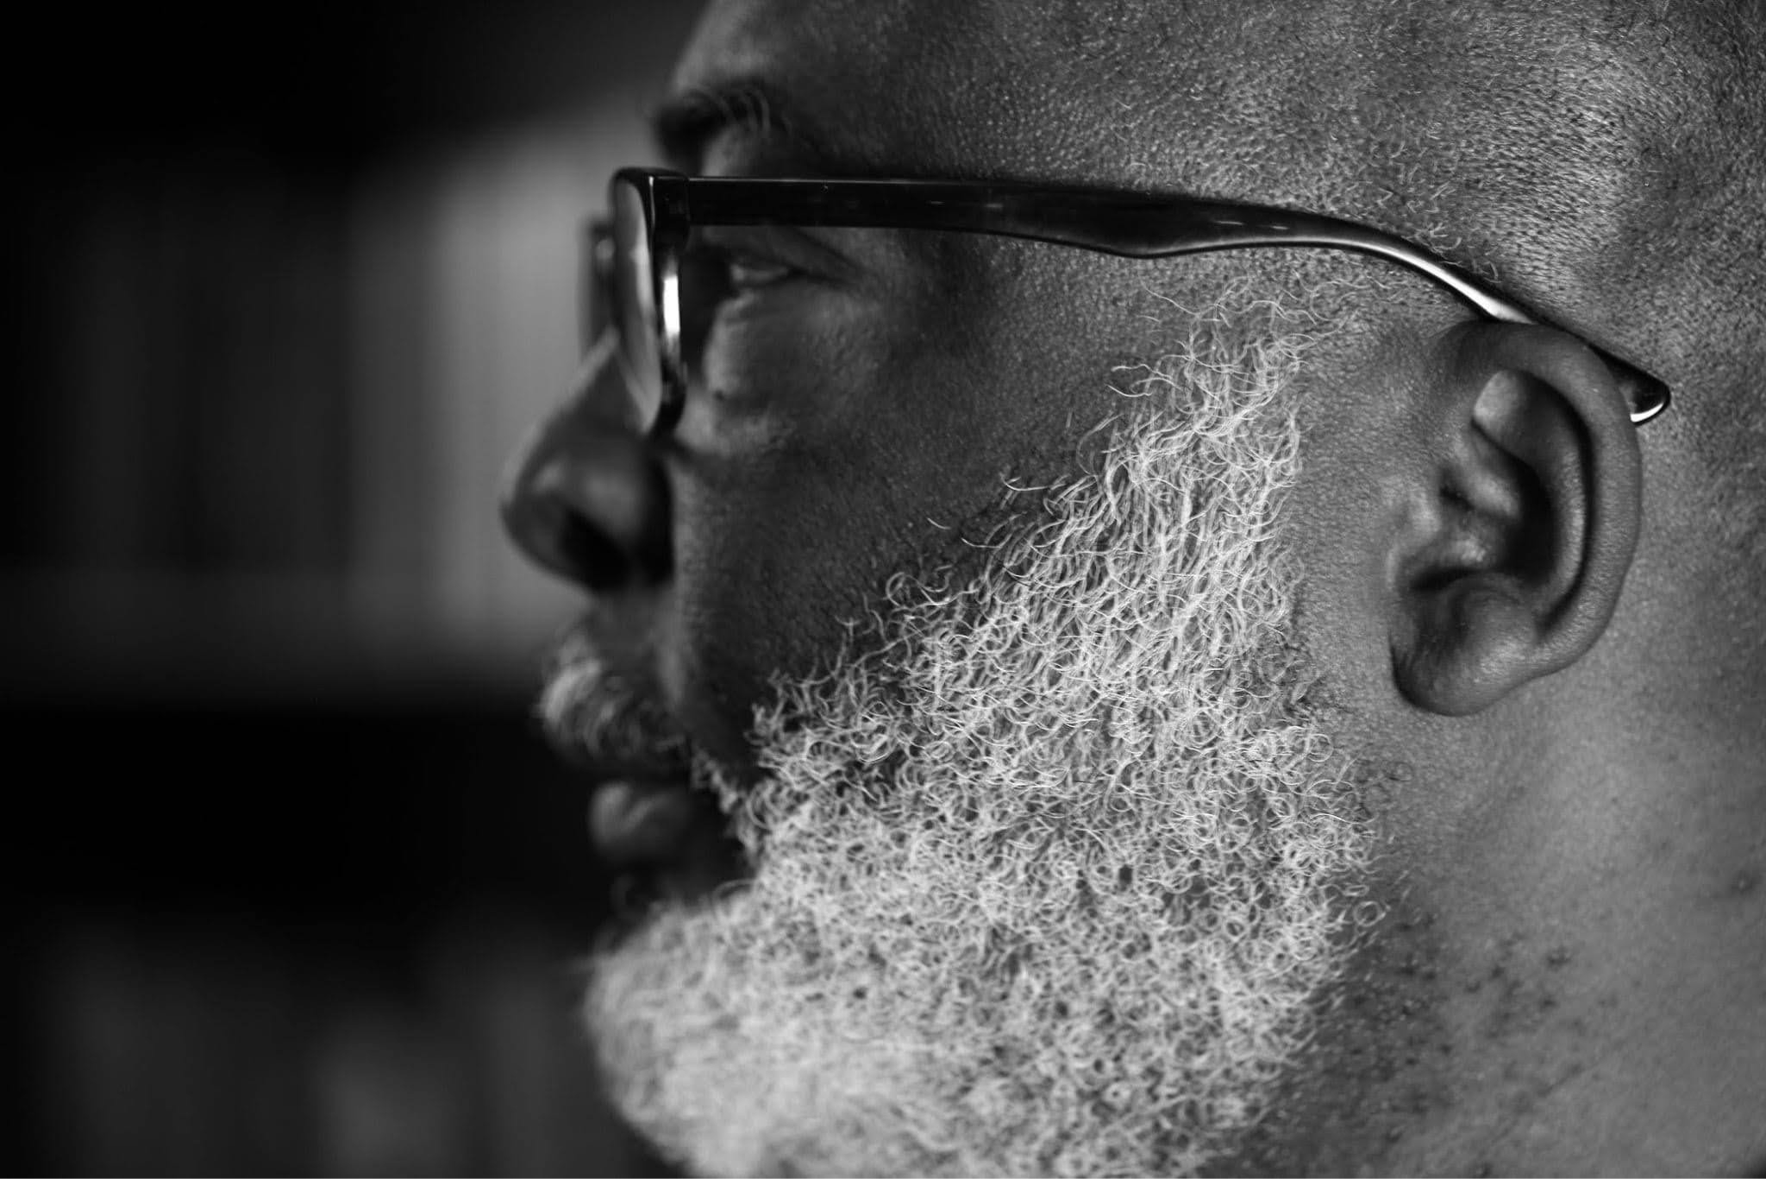

Ishmael Annobil is a London-based Ghanaian poet, filmmaker, journalist, emblemist and digital composer. Born in Accra, Ghana, in 1958, Ishmael started writing poetry at the age of 11, inspired by the great Ghanaian avant-gardist, Attukwei Okai, and entered journalism soon after high school. He has directed several keynote art documentaries, including Hornsleth: Product of Love, Kenji Yoshida: Artist of the Soul; and In the Presence of Awe: The Transvangarde.

Apart from Covid-19 Conversation, Ishmael has recently completed Linda Karshan: Choreographing the Page, a definitive documentary on Linda Karshan, and a series of collaborative video art of her groundbreaking Walked Drawings. Annobil’s surreal feature, Salamander Walks, is currently in post, and his forthcoming projects include Icarus, a folk sci-fi; Drosophila, a psychological thriller, and 4WM, a polemical film exploring Third World politics.

He has lived in Sudan and Kenya, where he performed his acclaimed poetry show, Criers on the Thresholds of Reality for refugees and the homeless. He is the founder/artistic director of the Welsh poetry festival, Iolo’s Children, and founder/editor of the now defunct Circa21 Newspaper, Wales’ first serious arts publication. A master photographer, and pioneer of important low-light techniques, Ishmael’s photography has been published in prominent publications, including The Independent Newspaper, and the prestigious French magazine M3. He was Anthologised in Another English: Anglophone Poems from Around the World (The Poetry Foundation, America, 2014).

Annobil has published two books of poetry, namely Seven Horn Elegy and Ethiop; a monograph of modern emblems for the Gadangme people, Abetei; a major photographic monograph of photography, Insomnia; and one music album, Zingliwu. He is currently finishing Inklings of Clay, an historical novella set in post-war Ashanti, Ghana, and his third poetry collection, Promise of Feathers (or Bardo), a polemical cycle dedicated to women.

He is the founder/editor of online art and design journal Chiaroscuro Magazine, and founder/Producer of Stonedog Productions, a London film collective noted for derring-do filmmaking and poetics. He is an ardent surrealist and magical realists in all his artforms; a style he attributes to his reading of Kafka’s Metamorphosis at the age of 9, cemented by his encounter with Toni Morrison’s Song of Solomon, as he was finishing high school. He is also a passionate Saul Bellowphile, champion of the writings of the great Yiddish storyteller, Isaac Bashevis Singer, especially Shosha, and his alter ego, Gabriel Garcie Marquez. His poetry heroes include Kwame Senu Dawes and Attukwei Okai.

WEB: www.stonedog.info | ishmaelannobil.com | www.chiaroscuromagazine.com

BIOGRAPHICAL NOTES: JILL SILVERMAN VAN COENEGRACHTS (ASSOCIATE PRODUCER)

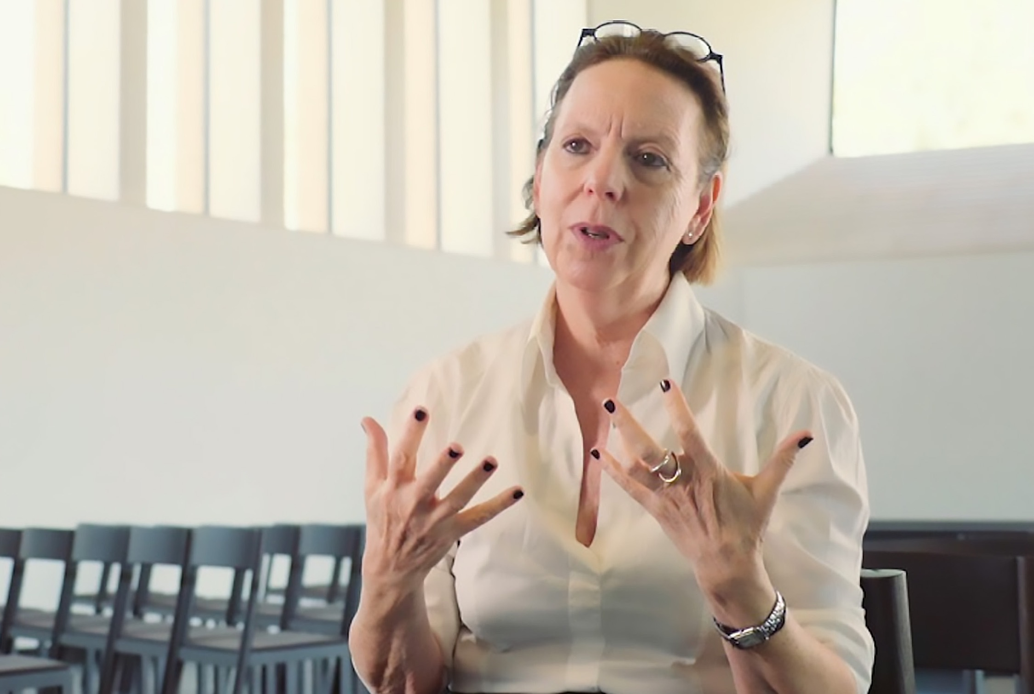

Jill Silverman van Coenegrachts is a renowned curator, gallerist, writer, and collaborative artists’ agent. JSVC has been at the forefront of the international contemporary art market for three decades. Her career has been note-worthy for the intense relationships with artists, development of institutional exhibitions as well as facilitating public and private collections in the acquisition of major works.

After 35 years managing and directing large international galleries, Jill Silverman van Coenegrachts launched JSVCProjects, a strategic international agency in 2013 to work directly with artists and designers, galleries, private collectors, museums, institutions and foundations. JSVC’s illustrious career path has included being Partner of Galerie Thaddaeus Ropac Paris/Salzburg 2005–2012; Managing Director, Lisson Gallery, London 1996–2005; Director, Barbra Mathes Gallery, New York, 1989–1990; Founder, Silverman Fine Art, New York, 1990–1995; Director, John Gibson Gallery, NYC, 1979–89. JSVC originated international museum exhibitions for Richard Deacon, Art & Language, Ilya and Emilia Kabakov, Tony Cragg, Anthony Gormly, Anish Kapoor, Sturtevant, Alex Katz, Anselm Kiefer, Jean-Marc Bustamante, Robert Longo, Jason Martin, Imi Knobel, Esther Shalev-Gerz, Koen Vanmechelen, and the Brick Sculptures of Per Kirkeby, and is currently planning Karshan’s showcase for the first Puglia Biennale, 2021.

She was profoundly influential in the creation of Linda Karshan’s Covid-19 works, signposting the artist remotely across the Atlantic. This ‘dowsing’ role carried through to the associate production of Linda Karshan: Covid-19 Conversation. JSVC’s synergetic relationship with artists stems from her poetic prescience, and deep understanding of the alchemical processes behind art. Hence her profound flair for positioning of art. Of note is her she commissioning of Linda Karshan’s first public ‘walked drawing’, Blackbird Song, for her inaugural Draw Art Fair, Saatchi Gallery, in 2018; bringing acclaim and an über-performative dimension to Karshan’s practice. She is Linda Karshan’s agent and collaborator.

In 2010 Jill Silverman Van Coenegrachts was awarded the Officier des Arts et Lettres by the French government for ten years of working on the committee for Foire Internationale d’Art Contemporain, bringing it back to the Grand Palais.

WEB: jsvcprojects.com

