Director’s Statement

LINDA KARSHAN: COVID-19 CONVERSATION

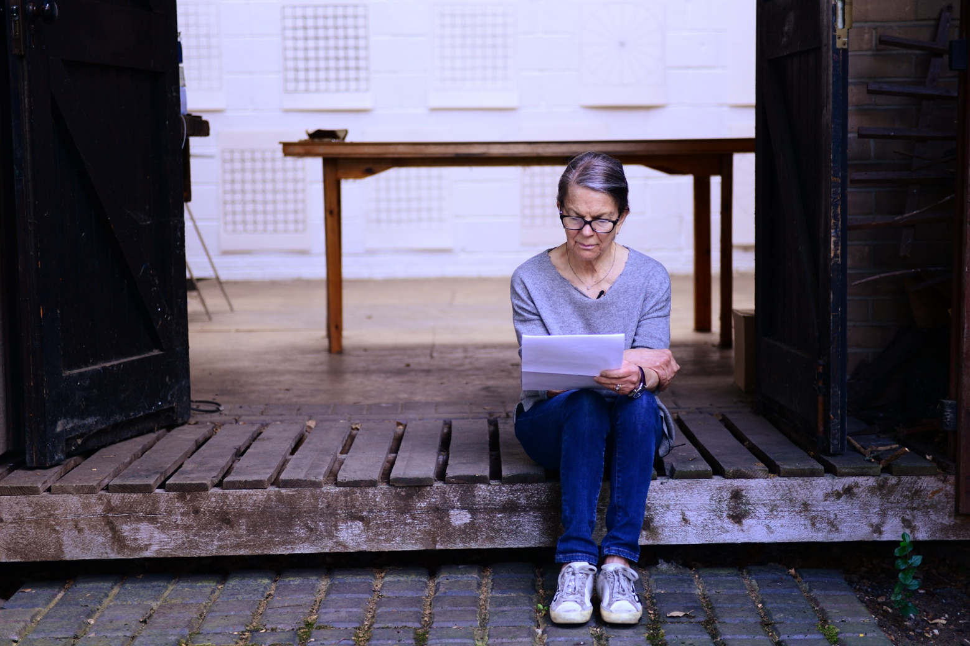

Sometime around April 2020, in the middle of the first global lockdown, Linda Karshan sent out a series of unique drawings to her team and collaborators. She had been working fervently throughout, in New York City. Such was my altered state that her art-laden emails behaved like dispatches from the other side of an apocalyptic dreamscape. They pierced the gloom like searchlights, woke me up, and prefigured for me a future rich with optimism and parables. A hyperbolic reaction, in retrospect, but I was soon vindicated by the fact that the new drawings were unrecognisable to Karshan herself!

Crucially, I knew to put my ear very closely to each dispatch, and “leave nothing to chance”, as Karshan often admonishes. Journalistic curiosity had nothing to do with it, nor the logics of conception and construction. It was beyond that level of interrogation. Too clinical for someone as close to Karshan’s practice as I am. Instead, like any human confronted with a new symbol, I was impelled to pursue the ‘sur-meaning’, or primitive essence, of the new drawings, to furnish my preferred matrix: oral history. I like oral history’s capacity for evolutional recall and re-interpretation, the otherworldly, and its unfettered will to celebrate awe.

In other words, the distillation of the sur-meaning requires a non-didactic approach. After all, abstraction comes from non-temporal origins. It cannot be codified, and so it doesn’t really have a fixed human language. Quite paradoxically, however, the only tool at my disposal was video, the very thing for freezing culture and meaning. But, to be fair, video isn’t all that rigid. It offers a lot of poetic and emotive latitude—just not exactly evolutional. But needs must, especially because I was privy to an even bigger urgency behind what Karshan was doing: the lockdown had invoked memories of her father’s polio affliction during the 1950s contagion, and his valiant battle against it, and so she, in turn, was pushing back at Covid-19, “because I can stand, and he could not”.
That was that. I knew posterity would judge me badly, if I did not give it the right kind of attention. Notwithstanding the viral palisade between us, the dire prospect of nations being hermetically sealed from each other, and the said limitations of video. I rehearsed my technical options mentally. A New York shoot via Zoom was one such, but I could not figure out how to capture any in situ value, in the circumstances. Besides, Karshan and I work differently—just the two us; me on up to four cameras, lighting, sound, while interviewing her. That fact, too, got me running outlandish configurations in my mind, driven by a frantic eye-hunger.

To add to the pressure, I was in the middle of extensive postproduction work on my definitive documentary, Linda Karshan: Choreographing the Page. There was also the danger of a new production influencing that, retroactively. But I am a documentarist, which makes me naturally prehensile in my asset acquisition, so I knew I would do it, anyway. But I would have to go to New York myself. All I needed was a clearing in the sky, and perhaps the end of Trumptopia, lest my name, Ishmael, be pinned up for target practice at JFK airport. (Unbelievable what a single, mendacious madman can do to the whole world.) That said, Karshan did not know of my plan!

By May, I was sure of Karshan’s trajectory. Such unrelenting pace. She was literally re-birthing herself and her practice. She discussed the automatic nature of the process in a jottings at the time; called it ‘channelling’, a process enabled by her artistic humility. In essence, the classic Karshan path: “drawing with method, but no plan”. A nod to the Greek concept of noumenon. This is because, as a trained psychologist, Karshan inhabits the ‘transitional space’ between the conscious and unconscious states, where creativity occurs. Abetted by a trained mind, I must add. Karshan had crystallized this idea in her 2005 rejoinder to Alberti’s dictum (Better to correct the errors of the mind than to remove them from the drawings.): “The mind, moved and warmed by experience gives greater promptness and dispatch to the work.”

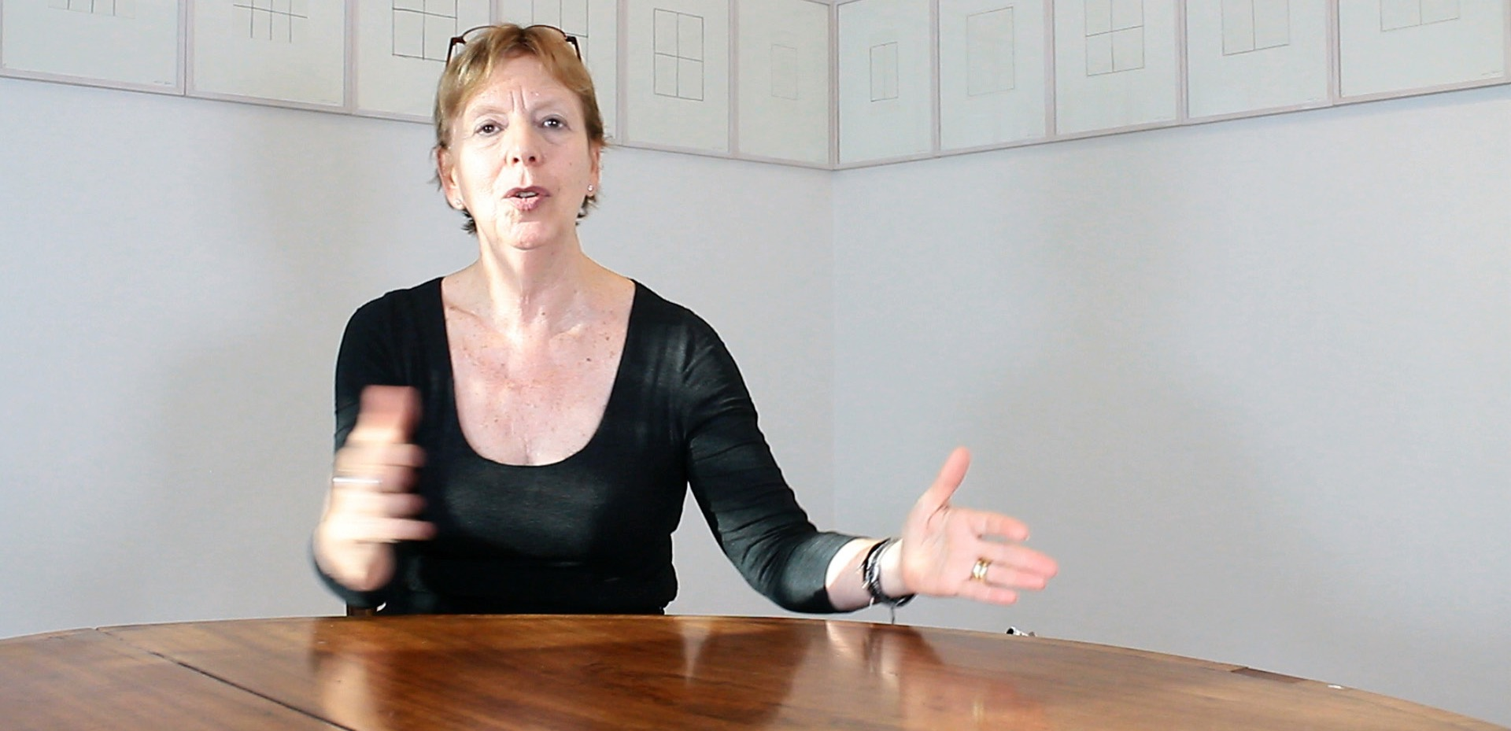
JILL SILVERMAN VAN COENEGRACHTS

Except, this time, Karshan had with her a travel companion: her super-perceptive and erudite agent, Jill Silverman van Coenegrachts, who had recognised the historical nature of this parable, right from the onset. It is fair to say that, she, too, was in need of a major trip out of the COVID stasis, and Karshan provided the right portal for it. Though ‘lockdowning’ in London and then Paris at the time, Coenegrachts was able to mine into Karshan’s liminal highway, with uncanny precision, quickening it with extraordinary signalling. “Listen to the hairs on the back of your neck”, is one of her notes to Karshan. I had a private booth for that light show, and I could see that the new art being borne by Karshan was unusual, like an ancestral codex. Atavism. I daresay, if inspiration is light that blazes from darkness into darkness, psyching poets and artists to a cosmic tapestry, then it takes a light bearer to enter that primordial space with them. That was the equation I was witnessing with these two great minds. Shamanism!
When Karshan finally came up for air, she had finished 80 drawings! Quite unprecedented! She had managed to fly back to London, in June, and continued adding to the cycle. I met with her at her son’s beautiful family house in Finsbury Park, on 7th August, and learned a lot more about her emotional landscape and psychological responses to internal and external stimuli, while channelling the works. I broached the idea of recording a conversation about it for the first time. She agreed, readily, with a new kind of elation in her eyes, and something of a seer’s mien. She was obviously glad I had understood her extraordinary journey. We set 17th August 2020 for the shoot.

I left our meeting with my own kind of elation; the threshing floor kind of elation, when a farmer has the net sum of nature’s blessings before his|her eyes. Because our easy, trusting approach is the result of five long years of creative winnowing between us. We have earned it. It has given us rare collaborative moments, including the founding of Karshan’s groundbreaking ‘walked drawing’ genre, in the chapter house of San Giorgio Maggiore abbey, in Venice, in 2018. It catalyses Karshan’s chance-taking, because she knows she can always count on a kindred lens.

Same day, I wrote to Coenegrachts: “... your input on the Covid-19 conversation would be a precious thing...Your motivational messages to Linda during the period were moving. And I remember thinking how what you were doing was exactly what film directors do, and that we are, in essence, carrying on a metaphysical trade...I learned that she [Karshan] has completed 80 pieces in all! Astounding! For sure, it will be difficult for Linda to whittle down, but I see a chance to capture the evolutionary process. We’ll see. I am excited. I look forward to the extra ‘ammo’ from your end.”

17th August, 2020, Karshan’s Studio, Dulwich, London:
For this shoot, I enlisted my trusty collaborator and cinematographer, Max Mallen. The plan was simple; he would film and take sound, and I would direct and interview/converse. We’d do a straight talking-head with Karshan; then a handheld walkthrough, with her elucidating a selection of the COVID drawings on the wall of her studio; and finish with Karshan reading a keynote jotting on the steps of her studio, as Coenegrachts had suggested in a recent phone conversation. The video format would be 4K on Blackmagic, in case the footage ended up as a projected video art piece.

The mood was just right. No airplanes overhead this time to disrupt the shoot like before, and the sun was seeping through the skylight at the right angle. We could fill lightly with an LED panel from her right-hand side. I had Coenegrachts’ ammo in hand: enchanted emails between her and Karshan, and Karshan’s telling jottings. At the right moment, I gave it to Karshan, and a palpable calmness came over her at once. She was obviously taken aback by the ‘stenography’ of her own ‘unconsciousness’. Meanwhile, Mallen and I got to work on our set-up, till Karshan signalled her readiness. However, to disentangle the tension between prep and action, we all confessed, in near-unison, a need for coffee. Karshan drove us all to her favourite Euro café in Dulwich Village, where we ended up splurging off-piste: dried porcini mushrooms for Karshan, expensive balsamic vinegar for me, and cakes for all. Mallen abstained from the retail therapy with palpable difficulty, but he couldn’t resist giving porcini cooking tips—he is an occasional YouTube chef.

The sunlight was still bold, when we got back to the studio, but we knew it wouldn’t last all day. Mallen and I adjusted our shooting schematics quickly, I reviewed my questions with Karshan, and then we entered the zone. Karshan opted to stand. She was relaxed and free. She fielded my questions with ease, till it became a real conversation. Next day I fed back to Coenegrachts, excitedly: “...If only science would let people accept what obviously resides beyond our minds! I had goosebumps when Linda read [her jotting] about her father. Wait till you hear the full story on film!!!”

But what to do with this magnificent conversation then? Should it be a document for archival or gallery purposes only, as I had originally planned? There was adequate precedent for that in my Karshan filmography. Or, should I graft it onto the bigger Choreographing the Page? Anyhow, I decided to review the raw footage in the can (consult the muses, as it were), to see what it would say to me. Suffice it to say, it gave me the same frisson I had felt while shooting it, and that meant only one thing: I would make a complete, standalone film. It felt like a eureka moment. A turn out it I was prepared for, because I had enough Karshan related matter on my computer to pull together any number of films about her. Curiously, I became preoccupied with the idea that I was making a free film for the world. Maybe because it was making itself. Maybe because it was telling me to do that.
I did not rue the absence of in situ footage of Karshan making these new works, although it meant going without a typical aspect of the Karshan paradigm: ‘footfalls’. I refer here to the sound of her foot tapping in time to her inner rhythm, and of the balletic positions she employs for kinesis, as she performs her work, like a marionette endowed with its own strategies for achieving ultimate grace — an image Karshan had proposed in an early jotting, and later by art historian Marilyn McCully, in reference to Heinrich von Kleist’s short story, On the Marionette Teatre:

“...I imagine myself suspended on a strong,
hovering over my drawing as it emerges through transitional space”.
(The important thing is to never force my movements.)
L.Karshan, 1999

“[Von Kleist sees the marionette] as an allegory of man,
controlled by the puppet-master but capable of movements
and gestures that are unpredictable, apparently spontaneous,
because the elements of control are sufficiently remote.”
M.McCully (Measure Without Measure), 2007

Good. If the marionette is capable of free will, then I could rely on Karshan’s inner rhythm beyond the work space: her movement or stillness, her words, and her thinking, as a vessel of art. Hopefully, the viewer should sense it in her phrasing and gestures and, if sensitive enough, in the drawings, too. In any case, it would invariably be the film’s ‘time signature’.

I was alone with these thoughts when I entered the cutting room. Alas, I hit a brick wall! In short, I had not prepared adequately for processing the unwieldy 4K video codec on my edit suite. All hell broke loose. Meanwhile, the film formulated itself at the back of my mind, right down to the score. Needless to say, the coincidence of my augury and the technical impasse was maddening. I became profoundly insomniac. I teetered on the edge of mania; nothing untoward, but a dread of losing my mind and not completing my baby. The long nights stretched before me with their unspent tyranny. And though I would normally sate that with night photography, insomnia left me too exhausted to lift a camera. Worse still, Covid-19 was humming even more insidiously over the city, like an alien spacecraft.

After two long months of fiddling, I finally got my edit suite in line. Then the precious footage unfurled on my timeline. Pre-programmed as I was, I sped through the cut. I made critical transpositions to replicate Karshan’s natural chronology as I knew it — a necessary manoeuvre because I had staggered my questions out of habit, to mitigate bathos during the shoot. Not that bathos is ever a prospect with Karshan— far from it. Speaking of which, I decided to throw out the handheld ‘walkthrough’ footage altogether. It was didactic. It was a mistake to have asked Karshan to enact it. It was against her intuition, and it showed in her body language and voice. It had to go!

The result was a clear but taut narrative, with a very poised Karshan conducting from the front and centre. Her easy articulacy was punchy but lambent, reminiscent of 1940s scholarly cinema. I knew I was on the cusp of achieving the minimalism or naturalism Karshan’s work demands. So, I decided to leave her voice well alone, without music. I saved that for the crescendo, an alluring montage of the Covid-19 works. I laid my own neoclassical composition, The Birth of Spring, on the montage, with an uncanny sense of solemnity, then sat back to watch it in full screen mode. Suddenly, the film lifted off the screen in front of me, announcing its true significance: Linda Karshan’s requiem for her remarkable father, Roger E. Joseph, and a sacrament of hope for a world in anguish. It is that immanent.

Ishmael Fiifi Annobil
Producer/Director
London, 18 January, 2021

