STONEDOG PRODUCTIONS

60 SWINLEY HOUSE, REDHILL STREET, LONDON, UK/ +44 7491 333424 / DIRECTOR@STONEDOG.INFO

PRESS RELEASE: (Use Immediately) / Date: 26 July 2021 / Dateline: London

COVID-19 INSPIRED DOCU WOWS FESTIVALS WORLDWIDE

Genre: Documentary Short / Running Time: 31.31 minutes / Format: HD

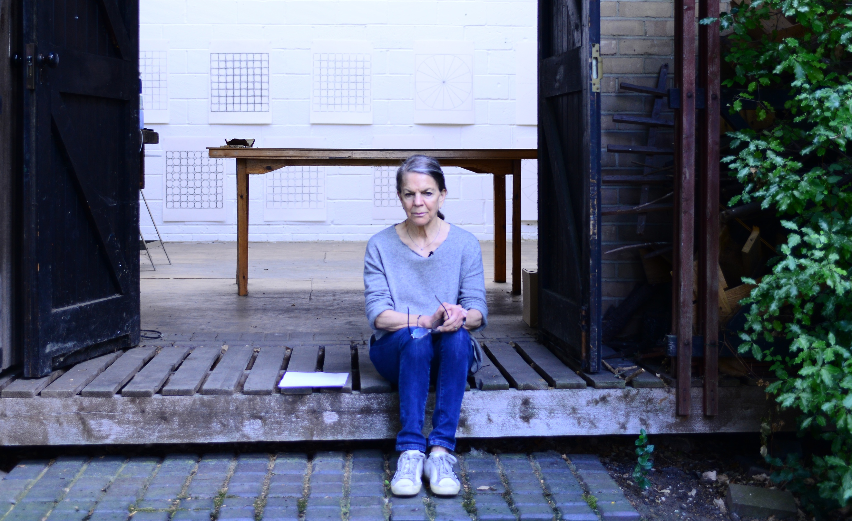

Linda Karshan: Covid-19 Conversation, an inspiring short documentary about American artist Linda Karshan's dramatic, creative rebirth under Covid-19 lockdown, is setting records on the international festival circuit. It has won three major Awards, two trophies, and an unprecedented number of nominations from prestigious film festivals from Europe, India, America, and Latin America.

Directed and edited by London-based Ghanaian poet/filmmaker Ishmael Fiifi Annobil, the film’s festival tally so far includes Winner, Best Short Documentary Award, Mykonos Film Festival (Greece); Winner of the Best Covid Special Film Award at Luleå International Film Festival (Sweden); Winner of the Diamond Award for Best Covid-Documentary Film, Nawada International Film Festival (India); Finalist, French Riviera Film Festival (Best Documentary) Nominee, Florence Film Awards (Italy); Nominee, Hollywood Blvd Film Festival (USA); Finalist, the Sweden Film Awards; Shortlisted, ARFF Berlin Film International Awards (Germany); Nominee by Five Continents International Film Festival (Venezuela); Nomination by Cinalfama International Film Screenings and Awards (Portugal. More laurels are anticipated by the director.

THE STORY: While under Covid-19 lockdown in New York, Linda Karshan recalled her father’s crippling polio affliction in the 1952/53 epidemic, the social alienation, and his gallant battle against it. This inspired her to “push back” by producing her most prolific body of work to date, without forethought or planning, as if in a trance, “…because I can stand, and he could not.” Covid-19 Conversation shows Linda Karshan at her most eloquent, offering a rare insight into her inner and outer impulses during her “channelling” of the unique art pieces, and the influential, ‘dowsing’ role played by her agent, Jill Silverman van Coenegrachts, throughout that process. Shot on a single day and on a single camera, Covid-19 Conversation features poignant anecdotes, rich family photographic archive, and it offers a mesmerising tableau of the actual Covid Works Linda created during her lockdown epiphany. Central to this lyrical film is the heroic figure of Linda’s father, Roger E. Joseph, a decorated World War II hero, who outlived his doctor’s pessimistic prognosis by sixteen years, resuming his legal practice in his family’s law chambers, and championing many humanitarian and human rights causes.

“Covid-19 Conversation is a testament to human resilience, and to the role of memory in the mark making of artists. It is Linda’s requiem for her father,” says Director Ishmael Fiifi Annobil.

A product of the dynamic Camden Town film collective, Stonedog Productions, Linda Karshan: Covid-19 Conversation reflects the collective’s derring-do approach that prioritises story over technology and budget. It is part of a wide suite of films on Linda Karshan by Ishmael Fiifi Annobil, including collaborative, ground-breaking video installation pieces.

For information about the film, crew and parsonages, visit: https://covid19conversation.info/

CREW:

Producer/Director/Editor: Ishmael Fiifi Annobil

Associate Producer: Jill Silverman van Coenegrachts

Cinematography/Sound: Max Mallen

Audio Post-Production: Nick Kulukundis

TRAILER: https://youtu.be/kaS_NHSi4YA

AWARDS AND ACCOLADES SO FAR:
WINS:
1. Best Covid19 Documentary Award, Luleå International Film Festival
2. Diamond Award for Best Covid Documentary, Nawada International Film Festival 2nd Season
3. Best Short Documentary Award, Mykonos Film Festival
NOMINATIONS:
1. Finalist, Best Documentary, French Riviera Film Festival
2. Finalist, Best Covid-19 Film, Sweden Film Awards
3. Shortlisted, Best Short Documentary, ARFF Berlin International Awards
4. Nominee, Hollywood Blvd Film Festival (Best Documentary)
5. Nominee, Florence Film Awards, (Best Short Documentary)
6. Nominee, Five Continents International Film Festival (best Documentary Short)
7. Nominee, 2021 ARFF Berlin International Awards (Best Short Documentary)
8. Nominee, Cinalfama Lisbon International Film Awards (Best Medium or Feature Length Film)
9. Nominee, Best Short Documentary, San Francisco Indie Short Festival

ENDS

EDITORS’ NOTES:

- WATCH THE FULL FILM: https://youtu.be/0aja6kUabpI
- Biographical Notes and the Director’s Statement attached to email
- For Trailer Download, Press Images, and Poster downloads, and more info, click on relevant blue button at: covid19conversation.info/media-room
- For more in-depth info about the film, crew and parsonages, visit: covid19conversation.info
- To requests interviews with Linda Karshan, contact: Jill Silverman van Coenegrachts at info@jsvcprojects.com
- Related websites: lindakarshanstudio.com / stonedog.info / thelindakarshanfilm.com

ABOUT STONEDOG PRODUCTIONS
Stonedog Productions is an international film collective, conceived in 2006 by Ghanaian poet, filmmaker and journalist Ishmael Fiifi Annobil to engage a small group of international film and photography professionals. Since then, Stonedog has since grown into one of the biggest film collectives in the United Kingdom, boasting 25 active members in the UK and abroad, and an impressive roll call of collaborators and associates. We are noted for our peerless storytelling, aesthetics, poetics and risk-taking. We embrace both realism and surrealism with equal passion, and flow seamlessly between the documentary and fiction idioms. Central to our approach are actors, whom we view as very important interpretative artists. Furthermore, we pride ourselves on our ability to do the impossible on any budget, without compromising our narrative or visual refinement. We believe in collaboration as a way round budgetary pressures, so as to concentrate on the playmaking process. This approach also guarantees our continual evolution as an art group.

BIOGRAPHICAL NOTES: LINDA KARSHAN

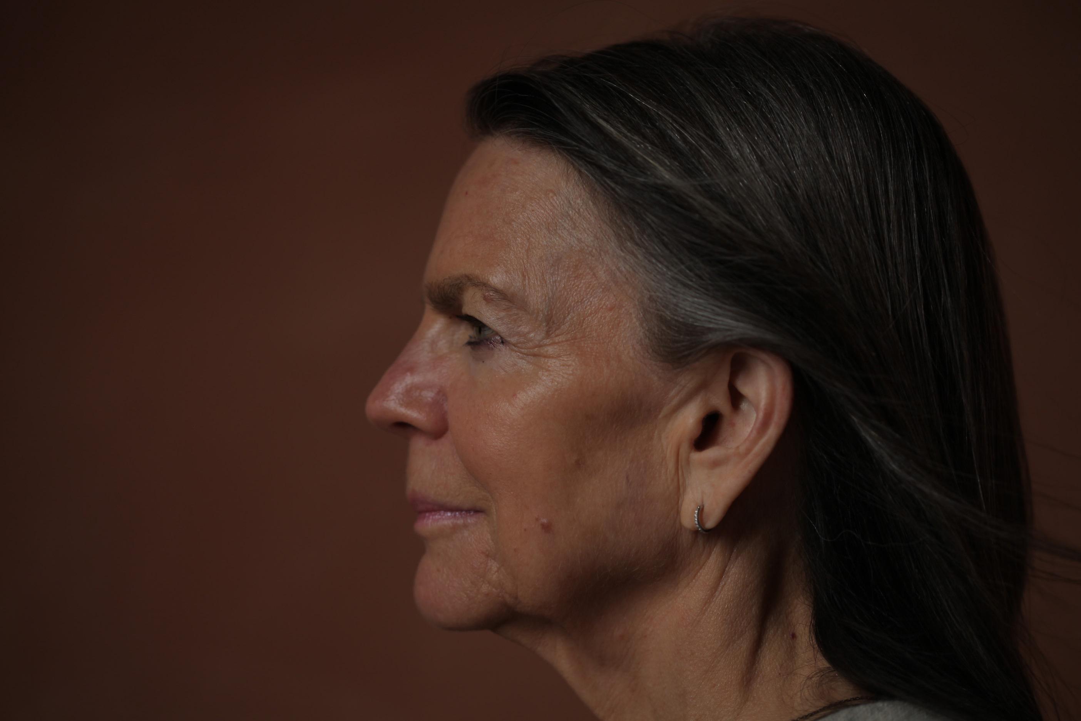
Linda Karshan | Photo by Nana Yaa Annobil

Linda Karshan is an American minimalist artist with an eminent practice that straddles the Atlantic. Drawing, printmaking, coupled with ambulatory and neo-choreographic technique, are the vehicles for her artistic expression, which is characterised by a disarming simplicity of form. She is noted for an irrepressible inventiveness that disregards boundaries (or edges), leading to groundbreaking outcomes, such as her ‘walked drawing’ genre, which entails her employing her feet as drawing points to enact walked lines and movements that reflect her internal rhythm. Drawing for Linda Karshan is a means of bridging the gap between a purely inner reality and a shared external reality, objectively perceived in the “transitional space” between the conscious and the unconscious. She draws with a method, but no plan, using her inner choreography and balletic norms for kinesis (see Linda Karshan: Movements, and Their Images and Linda Karshan: Choreographic Aspect)

Linda Karshan has a profound affinity with the lyricism of Greco-Roman text, art, and geometric archetypes; especially the Greek Cross, which underpins all her work. Her alter egos include Leonardo Da Vinci, Piero della Francesca, Cicero, and Samuel Beckett. Born in Minneapolis to a family of Jewish Romanian background, Linda Karshan has been resident in London since 1968. Her magnificent exhibitions include Equilibrio - Linda Karshan: Art, Architecture & Sacred Geometry in Conversation, San Giorgio Maggiore, Venice; Retrospective Drawing Exhibition 1992-2019 at DRAW Art Fair, Saatchi Gallery, London; and The Library for L’Aquila by Linda Karshan, for Nine Artists for Reconstruction, the library of Palazzo dell’Emiciclo, L’Aquila, Italy, and keynote shows at Galerie Werner Klein, Cologne, since 2008; Galerie Biedermann, Munich, since 1991; and Redfern Gallery, London, since 1995.
.
Linda Karshan’s drawings, prints and monographs are held in public and private collections, including the The British Library, The British Museum, The Courtauld Institute of Art, Sir John Soane’s Museum, Tate Modern, The Arts Council Collection, The Ashmolean Museum, Kettle’s Yard, Middlesbrough Museum of Modern Art (MIMA), Fine Arts Museums of San Francisco, Fogg Museum, Harvard University, Walker Art Center, Minneapolis, The Morgan Library, and Metropolitan Museum of Art has recently acquired thirteen of her prints.

Linda Karshan was educated at Skidmore College, Saratoga Springs, NY (1965-67); the Sorbonne, Paris (1967-68); and the Slade School of Art, University College London (1969). In 1983, she earned a Masters in Humanistic Psychology from Antioch Centre for British Studies, London. She has recently been made an Honorary Trustee of The Courtauld Institute. She is represented by Jill Silverman van Coenegracts (JSVCProjects) and The Redfern Gallery, London.

WEB: lindakarshanstudio.com | jsvcprojects.com | www.redfern-gallery.com | thelindakarshanfilm.com

BIOGRAPHICAL NOTES: ISHMAEL FIIFI ANNOBIL (DIRECTOR)

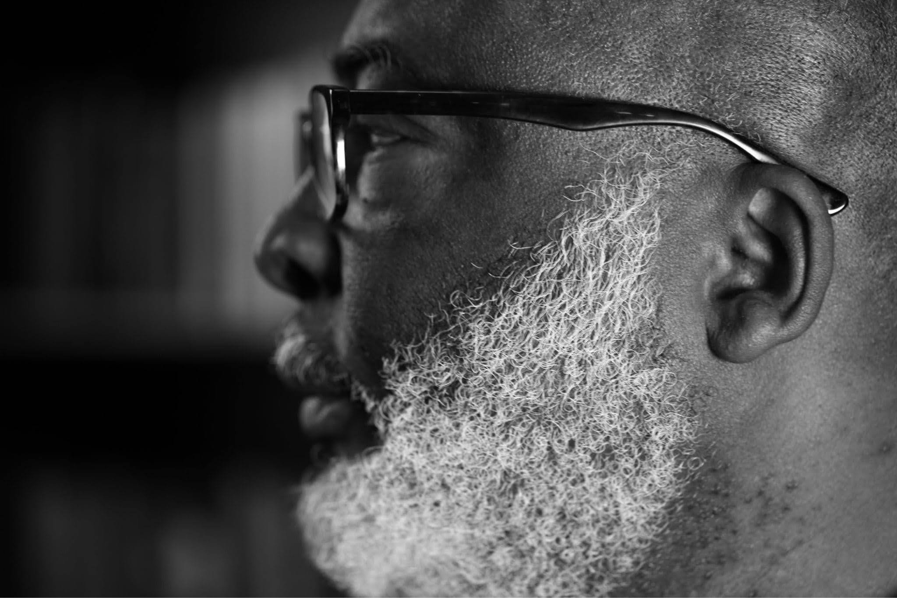
Ishmael Annobil | photo by Nana Yaa Annobil

Ishmael Annobil is a London-based Ghanaian poet, filmmaker, journalist, emblemist and digital composer. Born in Accra, Ghana, in 1958, Ishmael started writing poetry at the age of 11, inspired by the great Ghanaian avant-gardist, Attukwei Okai, and entered journalism soon after high school. He has directed several keynote art documentaries, including Hornsleth: Product of Love, Kenji Yoshida: Artist of the Soul; and In the Presence of Awe: The Transvangarde.

Apart from Covid-19 Conversation, Ishmael has recently completed Linda Karshan: Choreographing the Page, a definitive documentary on Linda Karshan, and a series of collaborative video art of her groundbreaking Walked Drawings. Annobil’s surreal feature, Salamander Walks, is currently in post, and his forthcoming projects include Icarus, a folk sci-fi; Drosophila, a psychological thriller, and 4WM, a polemical film exploring Third World politics.

He has lived in Sudan and Kenya, where he performed his acclaimed poetry show, Criers on the Thresholds of Reality for refugees and the homeless. He is the founder/artistic director of the Welsh poetry festival, Iolo’s Children, and founder/editor of the now defunct Circa21 Newspaper, Wales’ first serious arts publication. A master photographer, and pioneer of important low-light techniques, Ishmael’s photography has been published in prominent publications, including The Independent Newspaper, and the prestigious French magazine M3. He was Anthologised in Another English: Anglophone Poems from Around the World (The Poetry Foundation, America, 2014).

Annobil has published two books of poetry, namely Seven Horn Elegy and Ethiop; a monograph of modern emblems for the Gadangme people, Abetei; a major photographic monograph of photography, Insomnia; and one music album, Zingliwu. He is currently finishing Inklings of Clay, an historical novella set in post-war Ashanti, Ghana, and his third poetry collection, Promise of Feathers (or Bardo), a polemical cycle dedicated to women.

He is the founder/editor of online art and design journal Chiaroscuro Magazine, and founder/Producer of Stonedog Productions, a London film collective noted for derring-do filmmaking and poetics. He is an ardent surrealist and magical realists in all his artforms; a style he attributes to his reading of Kafka’s Metamorphosis at the age of 9, cemented by his encounter with Toni Morrison’s Song of Solomon, as he was finishing high school. He is also a passionate Saul Bellowphile, champion of the writings of the great Yiddish storyteller, Isaac Bashevis Singer, especially Shosha, and his alter ego, Gabriel Garcie Marquez. His poetry heroes include Kwame Senu Dawes and Attukwei Okai.

WEB: www.stonedog.info | ishmaelannobil.com | www.chiaroscuromagazine.com

BIOGRAPHICAL NOTES: JILL SILVERMAN VAN COENEGRACHTS (ASSOCIATE PRODUCER)

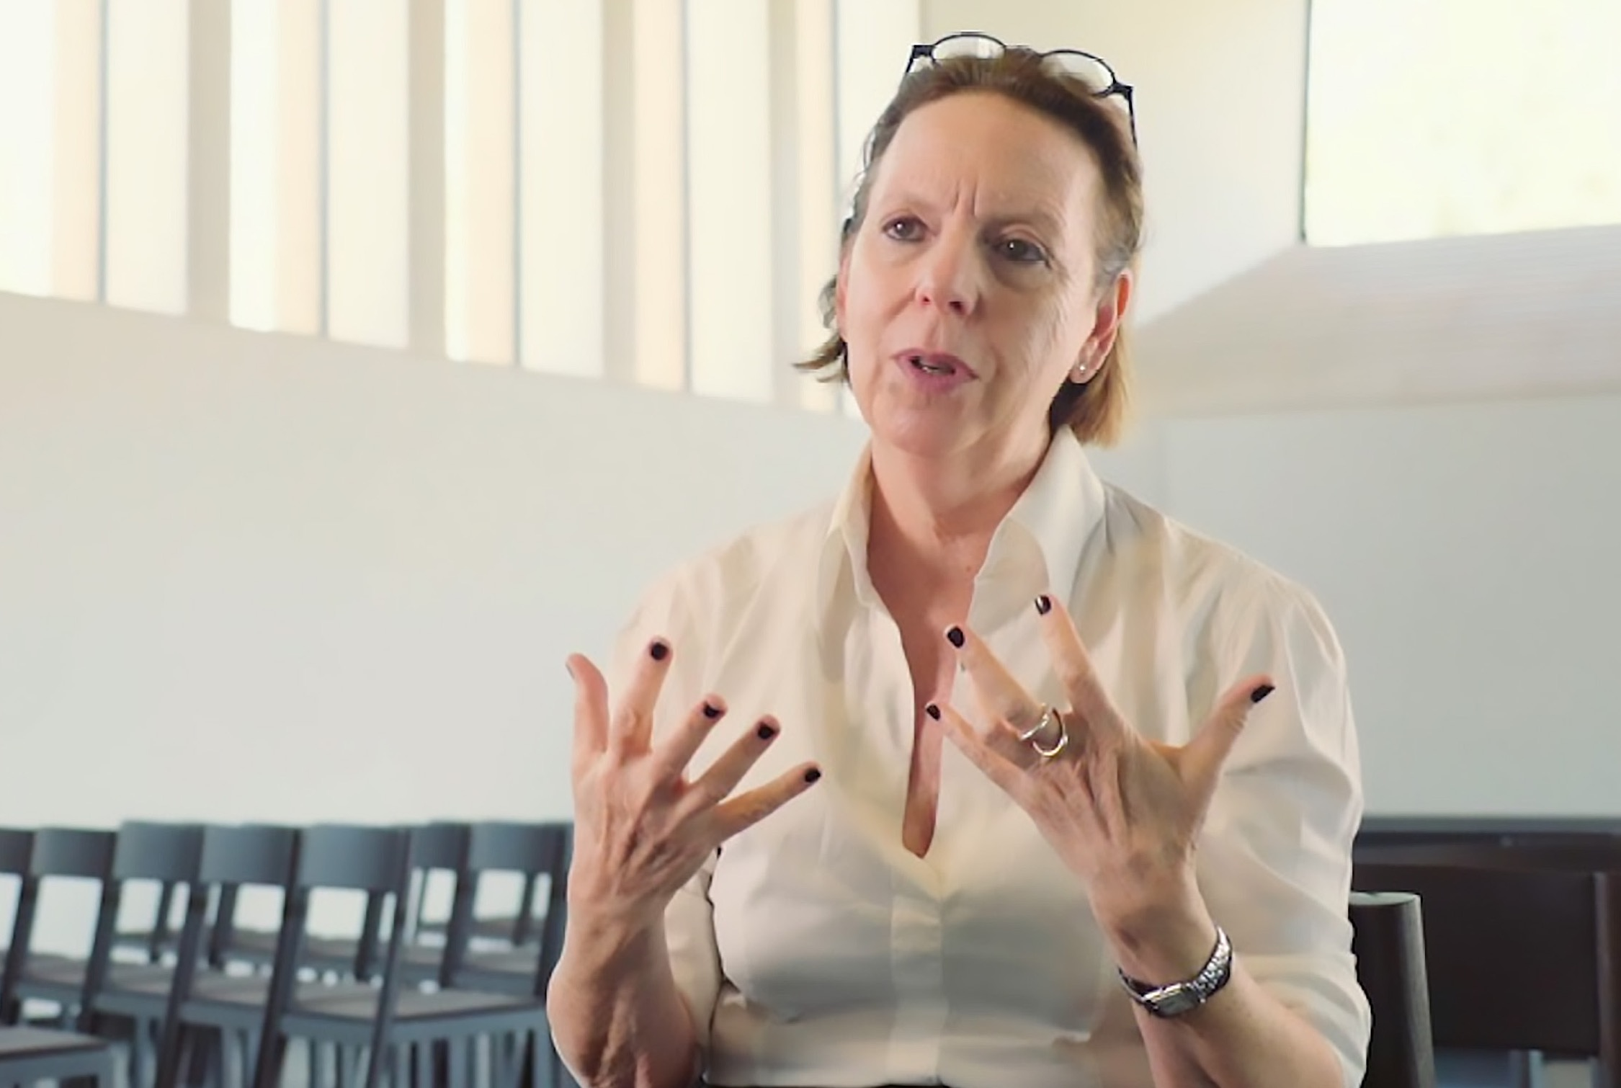
Jill Silverman van Coenegrachts | Photo by Studiotropics

Jill Silverman van Coenegrachts is a renowned curator, gallerist, writer, and collaborative artists’ agent. JSVC has been at the forefront of the international contemporary art market for three decades. Her career has been note-worthy for the intense relationships with artists, development of institutional exhibitions as well as facilitating public and private collections in the acquisition of major works.

After 35 years managing and directing large international galleries, Jill Silverman van Coenegrachts launched JSVCProjects, a strategic international agency in 2013 to work directly with artists and designers, galleries, private collectors, museums, institutions and foundations. JSVC’s illustrious career path has included being Partner of Galerie Thaddaeus Ropac Paris/Salzburg 2005–2012; Managing Director, Lisson Gallery, London 1996–2005; Director, Barbra Mathes Gallery, New York, 1989–1990; Founder, Silverman Fine Art, New York, 1990–1995; Director, John Gibson Gallery, NYC, 1979–89. JSVC originated international museum exhibitions for Richard Deacon, Art & Language, Ilya and Emilia Kabakov, Tony Cragg, Anthony Gormly, Anish Kapoor, Sturtevant, Alex Katz, Anselm Kiefer, Jean-Marc Bustamante, Robert Longo, Jason Martin, Imi Knobel, Esther Shalev-Gerz, Koen Vanmechelen, and the Brick Sculptures of Per Kirkeby, and is currently planning Karshan’s showcase for the first Puglia Biennale, 2021.

She was profoundly influential in the creation of Linda Karshan’s Covid-19 works, signposting the artist remotely across the Atlantic. This ‘dowsing’ role carried through to the associate production of Linda Karshan: Covid-19 Conversation. JSVC’s synergetic relationship with artists stems from her poetic prescience, and deep understanding of the alchemical processes behind art. Hence her profound flair for positioning of art. Of note is her she commissioning of Linda Karshan’s first public ‘walked drawing’, Blackbird Song, for her inaugural Draw Art Fair, Saatchi Gallery, in 2018; bringing acclaim and an über-performative dimension to Karshan’s practice. She is Linda Karshan’s agent and collaborator.

In 2010 Jill Silverman Van Coenegrachts was awarded the Officier des Arts et Lettres by the French government for ten years of working on the committee for Foire Internationale d’Art Contemporain, bringing it back to the Grand Palais.

WEB: jsvcprojects.com

Director’s Statement:

Linda Karshan: Covid-19 Conversation

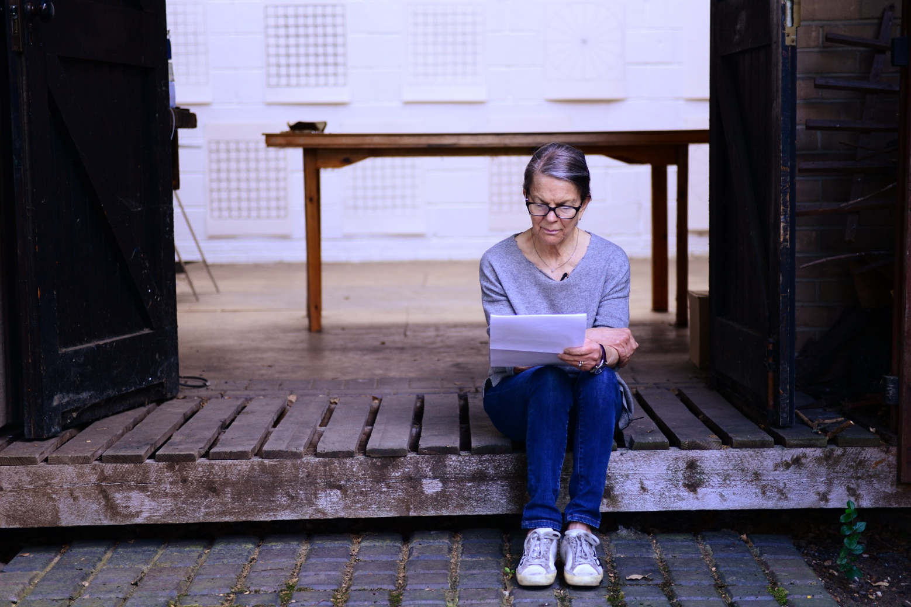

Sometime around April 2020, in the middle of the first global lockdown, Linda Karshan sent out a series of unique drawings to her team and collaborators. She had been working fervently throughout, in New York City. Such was my altered state that her art-laden emails behaved like dispatches from the other side of an apocalyptic dreamscape. They pierced the gloom like searchlights, woke me up, and prefigured for me a future rich with optimism and parables. A hyperbolic reaction, in retrospect, but I was soon vindicated by the fact that the new drawings were unrecognisable to Karshan herself!

Crucially, I knew to put my ear very closely to each dispatch, and “leave nothing to chance”, as Karshan often admonishes. Journalistic curiosity had nothing to do with it, nor the logics of conception and construction. It was beyond that level of interrogation. Too clinical for someone as close to Karshan’s practice as I am. Instead, like any human confronted with a new symbol, I was impelled to pursue the ‘sur-meaning’, or primitive essence, of the new drawings, to furnish my preferred matrix: oral history. I like oral history’s capacity for evolutional recall and re-interpretation, the otherworldly, and its unfettered will to celebrate awe.

In other words, the distillation of the sur-meaning requires a non-didactic approach. After all, abstraction comes from non-temporal origins. It cannot be codified, and so it doesn’t really have a fixed human language. Quite paradoxically, however, the only tool at my disposal was video, the very thing for freezing culture and meaning. But, to be fair, video isn’t all that rigid. It offers a lot of poetic and emotive latitude—just not exactly evolutional. But needs must, especially because I was privy to an even bigger urgency behind what Karshan was doing: the lockdown had invoked memories of her father’s polio affliction during the 1950s contagion, and his valiant battle against it, and so she, in turn, was pushing back at Covid-19, “because I can stand, and he could not”.
That was that. I knew posterity would judge me badly, if I did not give it the right kind of attention. Notwithstanding the viral palisade between us, the dire prospect of nations being hermetically sealed from each other, and the said limitations of video. I rehearsed my technical options mentally. A New York shoot via Zoom was one such, but I could not figure out how to capture any in situ value, in the circumstances. Besides, Karshan and I work differently—just the two us; me on up to four cameras, lighting, sound, while interviewing her. That fact, too, got me running outlandish configurations in my mind, driven by a frantic eye-hunger.

To add to the pressure, I was in the middle of extensive postproduction work on my definitive documentary, Linda Karshan: Choreographing the Page. There was also the danger of a new production influencing that, retroactively. But I am a documentarist, which makes me naturally prehensile in my asset acquisition, so I knew I would do it, anyway. But I would have to go to New York myself. All I needed was a clearing in the sky, and perhaps the end of Trumptopia, lest my name, Ishmael, be pinned up for target practice at JFK airport. (Unbelievable what a single, mendacious madman can do to the whole world.) That said, Karshan did not know of my plan!

By May, I was sure of Karshan’s trajectory. Such unrelenting pace. She was literally re-birthing herself and her practice. She discussed the automatic nature of the process in a jottings at the time; called it ‘channelling’, a process enabled by her artistic humility. In essence, the classic Karshan path: “drawing with method, but no plan”. A nod to the Greek concept of noumenon. This is because, as a trained psychologist, Karshan inhabits the ‘transitional space’ between the conscious and unconscious states, where creativity occurs. Abetted by a trained mind, I must add. Karshan had crystallized this idea in her 2005 rejoinder to Alberti’s dictum (Better to correct the errors of the mind than to remove them from the drawings.): “The mind, moved and warmed by experience gives greater promptness and dispatch to the work.”

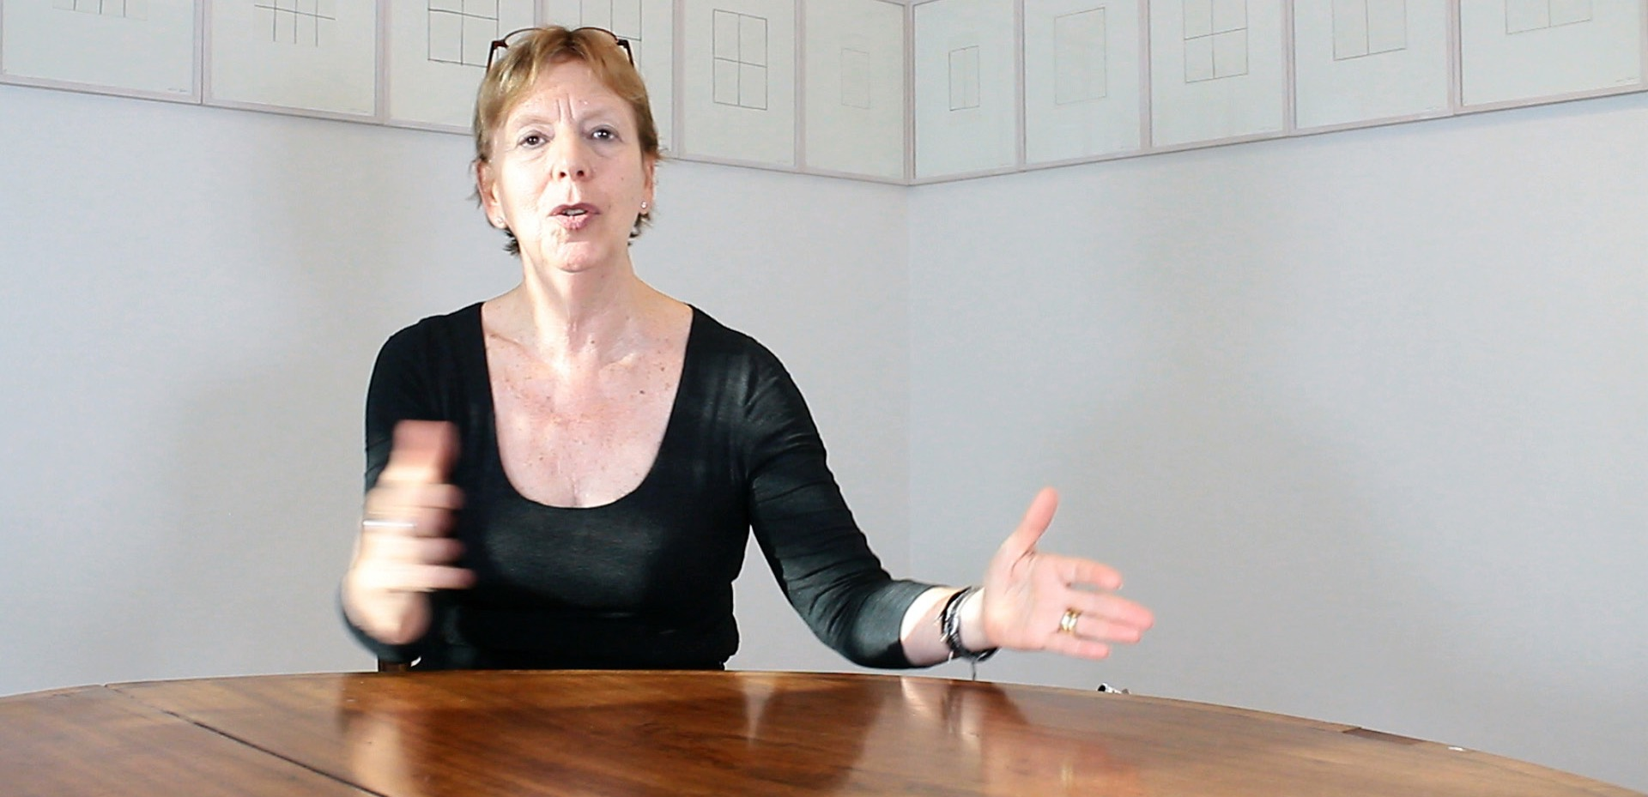

Jill Silverman Van Coenegrachts

Except, this time, Karshan had with her a travel companion: her super-perceptive and erudite agent, Jill Silverman van Coenegrachts, who had recognised the historical nature of this parable, right from the onset. It is fair to say that, she, too, was in need of a major trip out of the COVID stasis, and Karshan provided the right portal for it. Though ‘lockdowning’ in London and then Paris at the time, Coenegrachts was able to mine into Karshan’s liminal highway, with uncanny precision, quickening it with extraordinary signalling. “Listen to the hairs on the back of your neck”, is one of her notes to Karshan. I had a private booth for that light show, and I could see that the new art being borne by Karshan was unusual, like an ancestral codex. Atavism. I daresay, if inspiration is light that blazes from darkness into darkness, psyching poets and artists to a cosmic tapestry, then it takes a light bearer to enter that primordial space with them. That was the equation I was witnessing with these two great minds. Shamanism!
When Karshan finally came up for air, she had finished 80 drawings! Quite unprecedented! She had managed to fly back to London, in June, and continued adding to the cycle. I met with her at her son’s beautiful family house in Finsbury Park, on 7th August, and learned a lot more about her emotional landscape and psychological responses to internal and external stimuli, while channelling the works. I broached the idea of recording a conversation about it for the first time. She agreed, readily, with a new kind of elation in her eyes, and something of a seer’s mien. She was obviously glad I had understood her extraordinary journey. We set 17th August 2020 for the shoot.

I left our meeting with my own kind of elation; the threshing floor kind of elation, when a farmer has the net sum of nature’s blessings before his|her eyes. Because our easy, trusting approach is the result of five long years of creative winnowing between us. We have earned it. It has given us rare collaborative moments, including the founding of Karshan’s groundbreaking ‘walked drawing’ genre, in the chapter house of San Giorgio Maggiore abbey, in Venice, in 2018. It catalyses Karshan’s chance-taking, because she knows she can always count on a kindred lens.

Same day, I wrote to Coenegrachts: “... your input on the Covid-19 conversation would be a precious thing...Your motivational messages to Linda during the period were moving. And I remember thinking how what you were doing was exactly what film directors do, and that we are, in essence, carrying on a metaphysical trade...I learned that she [Karshan] has completed 80 pieces in all! Astounding! For sure, it will be difficult for Linda to whittle down, but I see a chance to capture the evolutionary process. We’ll see. I am excited. I look forward to the extra ‘ammo’ from your end.”

17th August, 2020, Karshan’s Studio, Dulwich, London:
For this shoot, I enlisted my trusty collaborator and cinematographer, Max Mallen. The plan was simple; he would film and take sound, and I would direct and interview/converse. We’d do a straight talking-head with Karshan; then a handheld walkthrough, with her elucidating a selection of the COVID drawings on the wall of her studio; and finish with Karshan reading a keynote jotting on the steps of her studio, as Coenegrachts had suggested in a recent phone conversation. The video format would be 4K on Blackmagic, in case the footage ended up as a projected video art piece.

The mood was just right. No airplanes overhead this time to disrupt the shoot like before, and the sun was seeping through the skylight at the right angle. We could fill lightly with an LED panel from her right-hand side. I had Coenegrachts’ ammo in hand: enchanted emails between her and Karshan, and Karshan’s telling jottings. At the right moment, I gave it to Karshan, and a palpable calmness came over her at once. She was obviously taken aback by the ‘stenography’ of her own ‘unconsciousness’. Meanwhile, Mallen and I got to work on our set-up, till Karshan signalled her readiness. However, to disentangle the tension between prep and action, we all confessed, in near-unison, a need for coffee. Karshan drove us all to her favourite Euro café in Dulwich Village, where we ended up splurging off-piste: dried porcini mushrooms for Karshan, expensive balsamic vinegar for me, and cakes for all. Mallen abstained from the retail therapy with palpable difficulty, but he couldn’t resist giving porcini cooking tips—he is an occasional YouTube chef.

The sunlight was still bold, when we got back to the studio, but we knew it wouldn’t last all day. Mallen and I adjusted our shooting schematics quickly, I reviewed my questions with Karshan, and then we entered the zone. Karshan opted to stand. She was relaxed and free. She fielded my questions with ease, till it became a real conversation. Next day I fed back to Coenegrachts, excitedly: “...If only science would let people accept what obviously resides beyond our minds! I had goosebumps when Linda read [her jotting] about her father. Wait till you hear the full story on film!!!”

But what to do with this magnificent conversation then? Should it be a document for archival or gallery purposes only, as I had originally planned? There was adequate precedent for that in my Karshan filmography. Or, should I graft it onto the bigger Choreographing the Page? Anyhow, I decided to review the raw footage in the can (consult the muses, as it were), to see what it would say to me. Suffice it to say, it gave me the same frisson I had felt while shooting it, and that meant only one thing: I would make a complete, standalone film. It felt like a eureka moment. A turn out it I was prepared for, because I had enough Karshan related matter on my computer to pull together any number of films about her. Curiously, I became preoccupied with the idea that I was making a free film for the world. Maybe because it was making itself. Maybe because it was telling me to do that.
I did not rue the absence of in situ footage of Karshan making these new works, although it meant going without a typical aspect of the Karshan paradigm: ‘footfalls’. I refer here to the sound of her foot tapping in time to her inner rhythm, and of the balletic positions she employs for kinesis, as she performs her work, like a marionette endowed with its own strategies for achieving ultimate grace — an image Karshan had proposed in an early jotting, and later by art historian Marilyn McCully, in reference to Heinrich von Kleist’s short story, On the Marionette Teatre:

“...I imagine myself suspended on a strong,
hovering over my drawing as it emerges through transitional space”.
(The important thing is to never force my movements.)
L.Karshan, 1999

“[Von Kleist sees the marionette] as an allegory of man,
controlled by the puppet-master but capable of movements
and gestures that are unpredictable, apparently spontaneous,
because the elements of control are sufficiently remote.”
M.McCully (Measure Without Measure), 2007

Good. If the marionette is capable of free will, then I could rely on Karshan’s inner rhythm beyond the work space: her movement or stillness, her words, and her thinking, as a vessel of art. Hopefully, the viewer should sense it in her phrasing and gestures and, if sensitive enough, in the drawings, too. In any case, it would invariably be the film’s ‘time signature’.

I was alone with these thoughts when I entered the cutting room. Alas, I hit a brick wall! In short, I had not prepared adequately for processing the unwieldy 4K video codec on my edit suite. All hell broke loose. Meanwhile, the film formulated itself at the back of my mind, right down to the score. Needless to say, the coincidence of my augury and the technical impasse was maddening. I became profoundly insomniac. I teetered on the edge of mania; nothing untoward, but a dread of losing my mind and not completing my baby. The long nights stretched before me with their unspent tyranny. And though I would normally sate that with night photography, insomnia left me too exhausted to lift a camera. Worse still, Covid-19 was humming even more insidiously over the city, like an alien spacecraft.

After two long months of fiddling, I finally got my edit suite in line. Then the precious footage unfurled on my timeline. Pre-programmed as I was, I sped through the cut. I made critical transpositions to replicate Karshan’s natural chronology as I knew it — a necessary manoeuvre because I had staggered my questions out of habit, to mitigate bathos during the shoot. Not that bathos is ever a prospect with Karshan— far from it. Speaking of which, I decided to throw out the handheld ‘walkthrough’ footage altogether. It was didactic. It was a mistake to have asked Karshan to enact it. It was against her intuition, and it showed in her body language and voice. It had to go!

The result was a clear but taut narrative, with a very poised Karshan conducting from the front and centre. Her easy articulacy was punchy but lambent, reminiscent of 1940s scholarly cinema. I knew I was on the cusp of achieving the minimalism or naturalism Karshan’s work demands. So, I decided to leave her voice well alone, without music. I saved that for the crescendo, an alluring montage of the Covid-19 works. I laid my own neoclassical composition, The Birth of Spring, on the montage, with an uncanny sense of solemnity, then sat back to watch it in full screen mode. Suddenly, the film lifted off the screen in front of me, announcing its true significance: Linda Karshan’s requiem for her remarkable father, Roger E. Joseph, and a sacrament of hope for a world in anguish. It is that immanent.

Ishmael Fiifi Annobil

Producer/Director
London, 18 January, 2021

British Covid Art Documentary Triumphs Internationally

